**23rd edition of the Precision Fair: meeting place for the international precision technology sector**

**The 23rd edition of the Precision Fair, the trade show where leading players and solutions in high- and ultra-precision technology come together, is just around the corner. On November 13 and 14, the Brabanthallen in &rsquo;s-Hertogenbosch will once again serve as the central meeting point for the international precision technology sector. "The role of the Dutch precision technology industry in serving international high-tech companies can serve as an example for many other countries and businesses. That&rsquo;s why this year we&rsquo;re focusing on the theme of 'International Collaboration,'&rdquo; says Bart Kooijmans, Program Manager of the Precision Fair.**

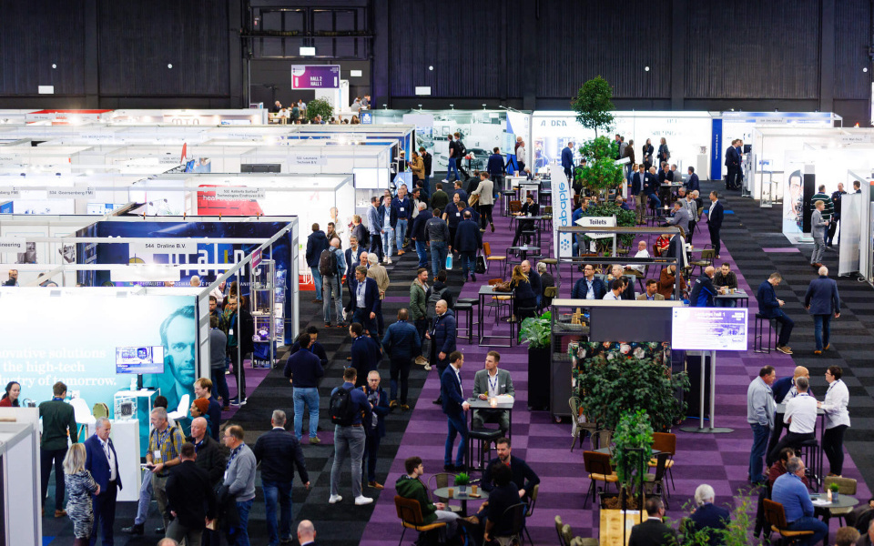

From smartphones and space telescopes to medical devices and chip machines, products are becoming faster, smarter, and more advanced. The development of these products requires complex technological solutions, where measuring, manufacturing, and constructing with increasingly smaller and more precise tolerances are crucial. The complexity of these solutions demands collaboration—not only with other technical disciplines but also with specialized companies, educational institutions, and research organizations. By sharing knowledge and working together, even on an international level, the boundaries of technology are pushed further. That’s the focus of the 23rd edition of the Precision Fair: pushing boundaries through international collaboration.

### Exhibition floor with 350 precision technology specialists

Over 350 exhibitors from the Netherlands and abroad will showcase their most advanced technologies and products on the exhibition floor. From precision tools and measuring instruments to automation solutions and high-tech materials, visitors can explore a wide range of groundbreaking innovations.

A central feature of the exhibition floor is the networking arena, where industry professionals come together to connect. Additionally, visitors can engage with over 30 industry associations, educational institutions, research institutes, large scientific projects, innovation projects, and student teams. Participants include Einstein Telescope, Big Science, Euspen, VDMA, Sirris, NEN, EPIC Photonics, Digital Industry Boost (a collaboration between Fontys, Summa College, Brainport Development, and Mikrocentrum), DSPE, RVO, TU Delft, TU/e, FPT-Vimag, Project MARCH, AeroDelft, and Superbike Twente.

### Six central themes

At the Precision Fair, attendees will meet top representatives from the industry, manufacturers, educational institutions, government agencies, technical universities, research organizations, and incubator programs. Over two days, visitors will discover high- and ultra-precision technological solutions based on the following themes: Mechatronic Engineering & Systems, Metrology, Vacuum & Clean, Micro Processing & Motion, Laser & Photonics, and Production for High Precision.

### First highlights announced!

With just 1.5 months to go, the organizers at Mikrocentrum are excited to announce the first highlights:

**Highlights for Wednesday, November 13:**

* Workshop: AI for High-Tech by Pipple
* Young Talent Pitch Program
* Big Science Conference Program featuring speakers from Nikhef, Maastricht University
* Workshop: The Importance of Vacuum and Ultra-Clean Vacuum for the Dutch Industry by TNO
* Lecture: 40 Years of ASML by Jan Jaap Kuit, VP EUV Development & Engineering at ASML
* Rien Koster Award Ceremony by DSPE
* International Meet & Match by BOM/Enterprise Europe Network

**Highlights for Thursday, November 14:**

* Celebration of Thermo Fisher Scientific’s 75th Anniversary
* Workshop: Retain Your Experts! The 3 Conditions They Value Most, by Spartners
* Masterclass: Geometric Dimensioning and Tolerancing by Mikrocentrum lecturer Firat Buyukcivelek
* Tech Sessions by EPIC
* Wim van der Hoek Award Ceremony by DPSE
* International Meet & Match by BOM/Enterprise Europe Network

### International Precision Conference on November 12

On November 12, the day before the Precision Fair, Mikrocentrum will host the new International Precision Conference at its location in Veldhoven. This conference offers international and national guests an in-depth look into the world of applied precision technology. Renowned keynote speakers from the top sector HTSM, ASML, ZEISS, Thermo Fisher Scientific, Advanced Packaging ASMPT, VDL ETG, TNO, and BIRDS will guide participants through the latest developments that shape the future of precision in design and production, as well as the importance of international collaboration. Interested parties can register separately for this event through the Precision Fair website:

<https://precisiebeurs.nl/en/international-precision-conference/>

### Free admission for visitors

The Precision Fair is free to attend. Registration is available online and at the registration desk in the Brabanthallen. More information about the conference program, exhibitors, and floor plan can be found at

[precisionfair.nl/en/](https://precisiebeurs.nl/en/)

.

### Partners

The Precision Fair is organized by Mikrocentrum in cooperation with/with support from CERN, NEVAC, BOM, KIVI, Manufacturing Knowledge Centre, Big Science, Photonics NL, Euspen, EPIC, Holland High Tech, Dutch Precision Technology, Vereniging ION, Enterprise Europe Network, Brainport Industries, VCCN, DSPE, and VDMA.

### Practical Information

* **Dates:** November 13 & 14, 2024
* **Opening Hours:** 10:00 AM - 5:00 PM
* **Location:** Brabanthallen, Diezekade 2, ’s-Hertogenbosch
* **Visitor Information:** [precisionfair.nl/en](https://precisiebeurs.nl/en/)
* **Exhibitor List and Floor Plan:** [precisionfair.nl/floorplan](https://precisiebeurs.nl/en/exhibition-floor/floor-plan/)
* **Register to Attend:** [precisionfair.nl/register](https://precisiebeurs.nl/en/register/)
* **Register for International Meet & Match:** [precision-fair-2024.b2match.io](https://precision-fair-2024.b2match.io/)

**Over: Mikrocentrum**

Mikrocentrum is het verbindende platform voor de hightech- en maakindustrie. Samen met onze leden, klanten en partners zetten we ons in voor een sterk innovatief ecosysteem, talentontwikkeling en voor de grote maatschappelijke uitdagingen van nu. Wij zijn een onafhankelijke stichting, een opleider, ontmoetingsplek, innovatieversneller en programmamaker. Met opleidingen, evenementen en het High Tech Platform bieden we voor iedereen uit de technologie een plek om kennis te vergroten, kennis te delen en elkaar te ontmoeten. Het uitgangspunt: samen bereiken we meer dan alleen.

**Newsroom**

Bekijk het volledige persbericht inclusief meer foto's en video's in onze Newsroom.

[Bekijk het volledige persbericht](https://mikrocentrum.presscloud.ai/pers/23rd-edition-of-the-precision-fair-meeting-place-for-the-international-precision-technology-sector)

[Bekijk alle voorgaande persberichten](https://mikrocentrum.presscloud.ai)