**23rd edition Precision Fair brought together the International Precision Technology world in 2 days**

**On November 13 and 14, the Brabanthallen in &rsquo;s-Hertogenbosch (NL) once again became the meeting point for the global precision technology industry. Over 6,100 (high-tech) professionals gathered at the 23rd edition of the Precision Fair to exchange knowledge about high- and ultra-precision technology. In addition to a wide range of networking opportunities, the fair became a dynamic hub for the high-tech sector. Knowledge sharing took center stage in the conference program, featuring insights into major European projects like the Einstein Telescope and discussions on the latest challenges and developments in high- and ultra-precision technology.**

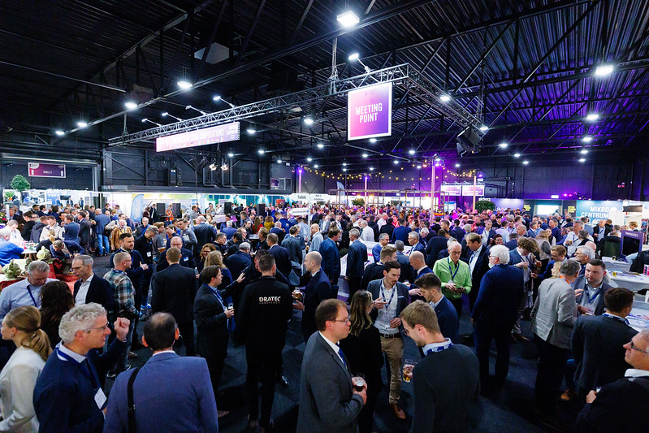

### International Collaboration key to strengthening the hightech sector’s leadership position

The Netherlands continues to strengthen its position as a global leader in the high-tech sector, a core contributor to the country’s economy. With approximately 50% of all R&D investments directed toward high-tech, the sector plays a vital role in innovation and economic growth. These were some of the key findings in the PwC report "Made in NL – The Value of the Dutch High-Tech Manufacturing Industry."

Maintaining and expanding this leading role requires more than technological advancements alone. Knowledge sharing, collaboration across the entire value chain, strong ties with education, and the execution of ambitious Big Science projects are all essential.

This is why international collaboration was the central theme of the conference program and the exhibition floor at the 2024 Precision Fair. The theme highlighted the importance of cross-border cooperation to tackle industry challenges and accelerate innovation.

Over 6,100 professionals from the Netherlands and abroad met, networked, and exchanged ideas. More than 375 exhibitors showcased their latest innovations, presenting a wide range of high-tech solutions.

### Record number of international delegations

“This year, more than ever, we see the entire precision technology value chain seeking new connections, knowledge sharing, and joint innovation. Interest from abroad is significant, and we are proud to have welcomed a record number of international delegations this year,” said Bart Kooijmans, Program Manager at Mikrocentrum, the organizer of the Precision Fair.

Among the international delegations were the short-pulse laser association from Lithuania with four companies and the Irish Precision Tooling & Machining Association, which attended with twelve companies. Delegations also came from Germany, Spain, Italy, and Canada, including the Canadian Photonics Association and the Swiss Precision Cluster. The large international participation underscores the growing importance of collaboration within the global precision technology sector.

### Spotlight on young tech talent: the future of hightech

To achieve the high-tech sector’s growth ambitions, the development of technical talent is indispensable. However, the inflow of technical talent remains a challenge. During the 2024 Precision Fair, several top student teams were showcased on the exhibition floor and in the pitch program to inspire and motivate the next generation.

Among the international delegations were the short-pulse laser association from Lithuania with four companies and the Irish Precision Tooling & Machining Association, which attended with twelve companies. Delegations also came from Germany, Spain, Italy, and Canada, including the Canadian Photonics Association and the Swiss Precision Cluster. The large international participation underscores the growing importance of collaboration within the global precision technology sector.

This year, the Precision Fair once again offered an extensive Young Talent program, highlighting students, PhD candidates, and startups. A key component was the annual Young Talent Award, with projects evaluated on social impact, technical feasibility, and innovation. Projects ranged from autonomous race cars to hydrogen-powered aircraft and rockets.

The Young Talent Award was ultimately awarded to Team Aero Delft, with DARE – Stratos V from Delft taking second place. The pitches demonstrated the immense talent and creativity of young engineers shaping the future of the high-tech industry.

### Knowledge program with presentations, workshops and masterclasses

Facilitating knowledge sharing about precision technology and high-tech extended beyond the meetings on the exhibition floor. The Precision Fair also hosted a diverse knowledge program, offering inspiration and opportunities for new connections.

Bart Kooijmans emphasized, “The knowledge program included a range of lectures and workshops on topics aligned with the international ambitions of the precision technology value chain.” Highlights included:

* Ultra-short pulse laser technology for 3D precision machining of transparent materials, by Martin Hermans – Laser Development Engineer, LouwersHanique
* The importance of vacuum and ultra-clean vacuum for the Dutch industry, by René Koops – Researcher, TNO Science and Industry
* Realization of the Extremely Large Telescope, by Ramon Navarro – Head of Optical Infrared R&D, NOVA
* GD&T in action: Applying theory to practice, by Firat Buyukcivelek – Trainer, Mikrocentrum and Mechanical Architect, ASML
* International Meet & Match, by Enterprise Europe Network

### Precision Fair 2025

Mikrocentrum will organize the next edition of the Precision Fair on November 12 & 13, 2025, once again at the Brabanthallen. For more information about the 2025 Precision Fair,

[visit this page.](https://precisiebeurs.nl/en/)

A detailed overview of the recent edition

[can be found here.](https://precisiebeurs.nl/en/previous-edition/)

**Over: Mikrocentrum**

Mikrocentrum is het verbindende platform voor de hightech- en maakindustrie. Samen met onze leden, klanten en partners zetten we ons in voor een sterk innovatief ecosysteem, talentontwikkeling en voor de grote maatschappelijke uitdagingen van nu. Wij zijn een onafhankelijke stichting, een opleider, ontmoetingsplek, innovatieversneller en programmamaker. Met opleidingen, evenementen en het High Tech Platform bieden we voor iedereen uit de technologie een plek om kennis te vergroten, kennis te delen en elkaar te ontmoeten. Het uitgangspunt: samen bereiken we meer dan alleen.

**Newsroom**

Bekijk het volledige persbericht inclusief meer foto's en video's in onze Newsroom.

[Bekijk het volledige persbericht](https://mikrocentrum.presscloud.ai/pers/23rd-edition-precision-fair-brought-together-the-international-precision-technology-world-in-2-days)

[Bekijk alle voorgaande persberichten](https://mikrocentrum.presscloud.ai)