**Future of plastics and rubber at the Kunststoffenbeurs 2023: sustainable, smart, and innovative!**

**Globally, the demand for sustainable materials and products is increasing. To achieve this, the plastics and rubber industry continuously works on making both its products and the entire process more sustainable: from procurement, design, and production to waste management. During the 24th edition of the Kunststoffenbeurs, on September 20th and 21st at the Brabanthallen in 's-Hertogenbosch, the possibilities of plastics and rubber for sustainable product development and production will be at the forefront. Since 1999, this two-day fair has been known as the central meeting place for the Benelux plastics and rubber chain**

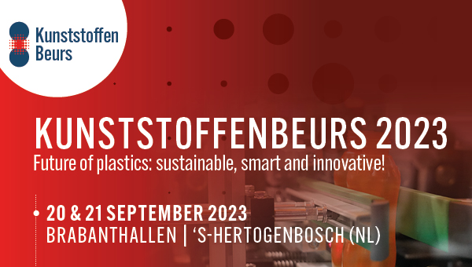

**Central focus on the possibilities of plastics and rubber for sustainable product development and production**

The Kunststoffenbeurs is the largest trade fair in the Benelux with a focus on plastics and rubber. Here, attendees discover the possibilities for sustainable product development and production. Thanks to the unique properties of plastics and rubber, there are endless opportunities in terms of color, shape, weight, as well as compatibility with other materials and applicability in various production techniques. These techniques include injection molding, thermoforming, vacuum forming, extrusion, and even 3D printing.

"This year, we are excited to bring together over 230 industry experts from the plastics and rubber industry with international and national visitors. The theme of this year's event is 'Future of Plastics,' which encompasses all the developments, initiatives, and new production techniques related to plastics. Think of opportunities for the industry in terms of sustainability, energy transition, product development, and innovations in machines for processing and shaping plastics," says Charlotte de Jong, program manager of the Kunststoffenbeurs.

**Meet over 230 specialized companies from the plastics and rubber industry**

On the exhibition floor, visitors will meet over 230 companies, knowledge and educational institutions, research projects, startups, and student teams specializing in areas such as plastic processing and shaping, product design and development, sustainability, machinery construction, surface technologies, molds, and injection molding.

**Machinesquare by Equip-Plast**

At the Machineplein by Equip-Plast, 20 international and national exhibitors will demonstrate state-of-the-art technology for the plastics and rubber industry, with a particular focus on sustainability. This is concretely translated into lower CO2 emissions and energy consumption. Sustainability is not just about recycling plastics; reducing energy consumption is also part of the solution. At the Machineplein, attendees will find excellent examples of fully electric and hybrid injection molding machines, as well as concrete applications and software for a circular injection molding process.

"Plastics are unfairly stigmatized. They are a material that ingeniously allows us to create a lot from few resources," says Bob Pieterse, marketing manager at Plastima and one of the exhibitors at the Machineplein. He is pleased with this year's theme of the Kunststoffenbeurs: "Proud of Plastics." The effects of regulations related to the EU's Green Deal are becoming visible, such as manufacturing companies having to provide CO2 emission data for the products they make. "This starts with the multinationals and gradually reaches the injection molders," says Robbert Weijers, sales manager at Arburg Benelux. Arburg is celebrating its centenary this year and will present a special jubilee machine at the Kunststoffenbeurs.

**Congress program and various areas featuring prominent industry figures**

Merijn Tinga, better known as the Plastic Soup Surfer, and Dirk Groot, also known as the Zwerfinator, have been actively engaged in the fight against plastic pollution, each in their own unique way, for quite some time. Both gentlemen will be keynote speakers in the promising congress program that closely aligns with the future of plastics: sustainable, smart, and innovative. During their presentations, they will discuss the possibilities of plastic, recycling, and share their own experiences.

Knowledge about the future of plastics will not only be shared during the congress program. Various areas, such as the Start-up, Knowledge & Education, Innovation, and 3D printing areas, will feature demonstrations of different companies' innovations, use cases, and developments in the plastics and rubber industry.

**Rethink Plastics Awards come to the Kunststoffenbeurs**

This year, the presentation of the Rethink Plastics Awards by the Federation NRK will take place during the Kunststoffenbeurs. Visitors can also visit the Rethink Plastics expo, where many examples of sustainably produced products will be showcased.

**A two-day trade fair serving as the meeting place for the entire Benelux plastics and rubber industry**

Since 1999, the Kunststoffenbeurs has been the trade fair for the entire Benelux plastics and rubber chain. Over the years, this trade fair has become the annual meeting point for everyone involved in the plastics and rubber industry, including product designers, manufacturers of consumer products, and those curious about the latest developments in plastics and rubber. It is also the place where collaborations can be formed for the (sustainable) future of plastics.

The Kunststoffenbeurs is free of charge for visitors on both days, but registration is required. This can be done through the website: www.kunststoffenbeurs.nl. More information for visitors and exhibitors can also be found on the website.

**Over: Mikrocentrum**

Mikrocentrum is het verbindende platform voor de hightech- en maakindustrie. Samen met onze leden, klanten en partners zetten we ons in voor een sterk innovatief ecosysteem, talentontwikkeling en voor de grote maatschappelijke uitdagingen van nu. Wij zijn een onafhankelijke stichting, een opleider, ontmoetingsplek, innovatieversneller en programmamaker. Met opleidingen, evenementen en het High Tech Platform bieden we voor iedereen uit de technologie een plek om kennis te vergroten, kennis te delen en elkaar te ontmoeten. Het uitgangspunt: samen bereiken we meer dan alleen.

**Newsroom**

Bekijk het volledige persbericht inclusief meer foto's en video's in onze Newsroom.

[Bekijk het volledige persbericht](https://mikrocentrum.presscloud.ai/pers/future-of-plastics-and-rubber-at-the-kunststoffenbeurs-2023-sustainable-smart-and-innovative)

[Bekijk alle voorgaande persberichten](https://mikrocentrum.presscloud.ai)