**International Precision Conference: leading keynote speakers from precisiontechnology sector**

**Mikrocentrum, platform organisation for the high-tech and manufacturing industries, will launch the new International Precision Conference on 12 November. In the lead-up to the Precision Fair, this conference offers international and national guests a deep dive into the world of applied precision technology. Prominent keynote speakers will discuss how collaborations within the Dutch ecosystem contribute to technological innovation and the future of precision in design and production.**

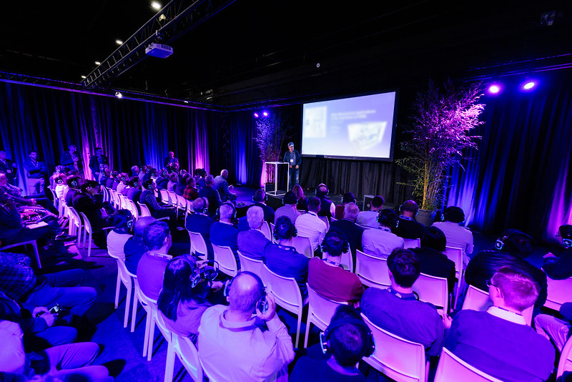

International collaboration is essential when developing and producing complex technical systems. Within the Dutch precision technology ecosystem and supply chain, collaboration is crucial. Speakers from the Top Sector HTSM, ASML, ZEISS, Thermo Fisher Scientific, Advanced Packaging ASMPT, VDL ETG, TNO, and BIRDS will share their vision on collaboration, the (technical) challenges involved, technological innovation, and how collaboration works in practice. Following the programme, international participants can also take part in company visits to various OEMs and Tier 1 suppliers in the Brainport region.

### The keynotespeakers

Under the guidance of chairpersons Henny Spaan (Director IBS Precision and Chair of VDMA EMINT) and Arnaud de Jong (Managing Director of TNO High Tech Industry), twelve keynote speakers will share their expertise and insights:

* *The Dutch way of innovation: the high tech eco-system in the Netherlands*  
  Marc Hendrikse, Figurehead of the Dutch Top Sector High Tech Systems and Materials (HTSM)  
    
  Hendrikse will kick off the conference programme with a comprehensive explanation of how the Dutch high-tech supply chain collaborates intensively. This unique way of working makes the Netherlands an excellent
* *ASML’s beginning, growth and future*  
  Martin van den Brink, Emeritus President and CTO of ASML  
  Van den Brink will take participants on a journey through the remarkable history of ASML and its world-changing technological innovations over the years: from the PAS2000 to the highly advanced High NA EUV system and beyond.
* *Collaboration in the eco-system: 15 companies cooperating in world’s most accurate measurement system for semiconductor*  
  Erik Loopstra, Fellow, ZEISS SMT GmbH Germany  
  Loopstra’s keynote will cover a large project to measure EUV mirrors with precision beyond the nanometre scale for ASML EUV machines. These mirrors, which are over 1.5 metres in diameter, require extraordinary accuracy, achieved through collaboration with 15 engineering companies in the Eindhoven region.
* *Research & development of the highest level of contamination control in the supply chain*  
  Ton Peijnenburg, CTO VDL Enabling Techologies Group & Kasper van den Broek, Tribologie expert and Contamination Control Architect at VDL Enabling Techologies Group  
  Peijnenburg and Van den Broek, both involved in the development of advanced contamination control methods, will share how they have achieved exceptional levels of cleanliness.
* *Designing solutions for major steps in the electronics manufacturing process*  
  Gary Widdowson, CTO Semi Solutions ASMPT , Advanced Packaging ASMPT, Singapore  
  ASMPT in Singapore produces a wide range of semiconductor equipment, covering the entire back-end of the semiconductor market with advanced assembly and packaging solutions for various industries. International collaboration is essential for this. Widdowson’s lecture will cover how they collaborate on an international scale to achieve technological innovation.
* *Technology innovation collaboration for Transmission Electron Microscope (TEM)*  
  Olivier Rainaut, Director R&D TEM Solutions, Thermo Fisher Scientific  
  Rainaut will provide a unique insight into the realisation of technological innovations in transmission electron microscopy, with the Titan Krios as a market leader. This microscope, which can visualise details down to one angstrom, is widely used in the semiconductor, materials science, and biological sciences sectors.
* *Cross-Domain Synergies: Leveraging Ultra Precision Technologies to Transform High-Tech Industries*  
  Helen Kardan, Director of Science and Technology, TNO High Tech Industry  
  Kardan will discuss how precision technologies can revolutionise high-tech sectors, drive innovation, and create transformative changes. Her lecture will inspire participants to transcend traditional boundaries and embrace future technological developments.
* *Authentic Innovation in the ASML way*  
  Patrick de Jager, BIRDS  
  De Jager has worked for many years in business development in the semiconductor industry, including at TNO and ASML, where he thrived in a creative and innovative environment. He recently decided to apply his expertise beyond semiconductors, focusing on creating value in sectors such as the energy transition and healthcare. In his lecture, he will share his inspiring story and new ambitions.

### More information

[The International Precision Conference](https://precisiebeurs.nl/en/international-precision-conference/)

will take place on 12 November 2024 at Mikrocentrum in Veldhoven. Participation fees apply.

[More information can be found at the eventpage.](https://precisiebeurs.nl/en/international-precision-conference/)

**Over: Mikrocentrum**

Mikrocentrum is het verbindende platform voor de hightech- en maakindustrie. Samen met onze leden, klanten en partners zetten we ons in voor een sterk innovatief ecosysteem, talentontwikkeling en voor de grote maatschappelijke uitdagingen van nu. Wij zijn een onafhankelijke stichting, een opleider, ontmoetingsplek, innovatieversneller en programmamaker. Met opleidingen, evenementen en het High Tech Platform bieden we voor iedereen uit de technologie een plek om kennis te vergroten, kennis te delen en elkaar te ontmoeten. Het uitgangspunt: samen bereiken we meer dan alleen.

**Newsroom**

Bekijk het volledige persbericht inclusief meer foto's en video's in onze Newsroom.

[Bekijk het volledige persbericht](https://mikrocentrum.presscloud.ai/pers/international-precision-conference-leading-keynote-speakers-from-precisiontechnology-sector)

[Bekijk alle voorgaande persberichten](https://mikrocentrum.presscloud.ai)