Precision Fair 2023 underscores the importance of international collaboration and knowledge sharing
The Netherlands aims to further strengthen its position as a leader in the hightechsector. This is not surprising, given that the hightechsector is a crucial pillar of the Dutch economy, responsible for approximately 50% of all R&amp;D investments in the country. To (continue) bolster this leadership role, more is needed. This requires knowledge sharing, connecting the entire chain, involvement from the education sector, the implementation of Big Science projects, and forging new collaborations. In the past week, on November 15 and 16, over 5900 (high-tech) professionals found their way to the 22nd edition of the Precision Fair, a growth of 15% compared to the previous edition. The fact that the high-tech sector wants to maintain its leadership role is evident from the fact that this edition was larger than ever.

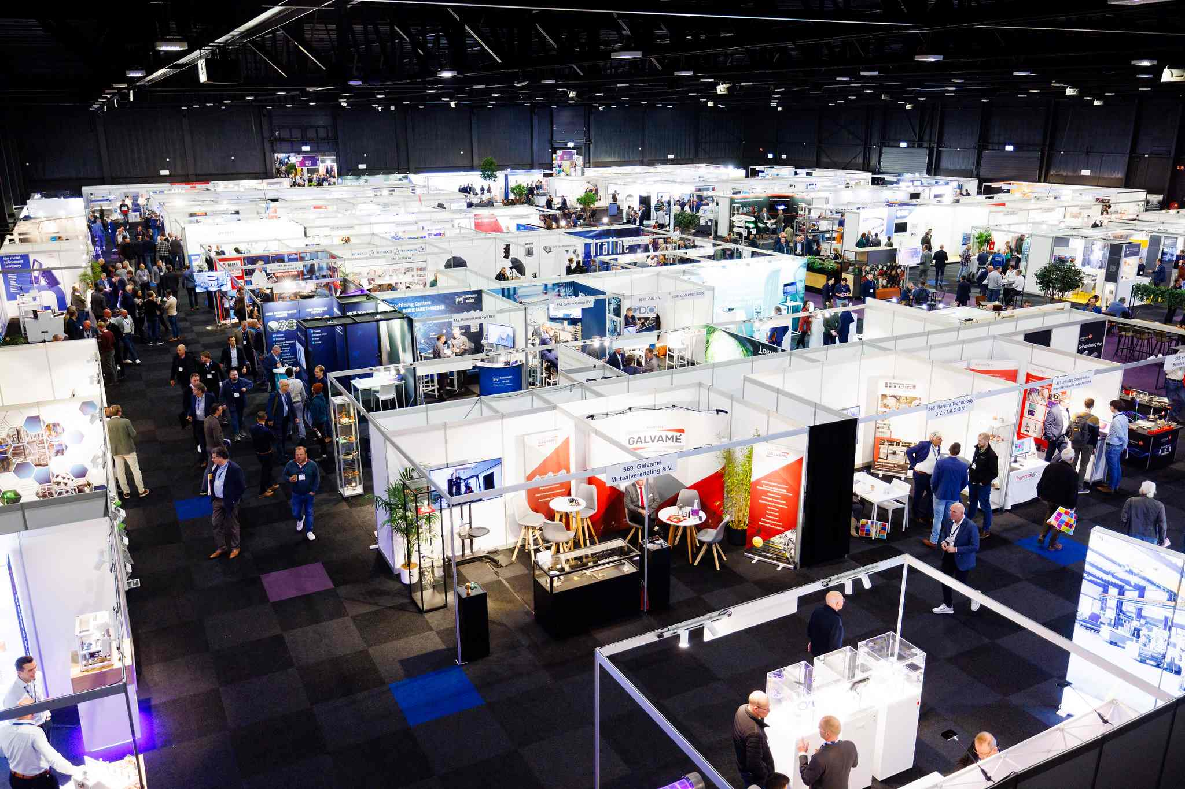

International ambition with a focus on joint innovation
The Precision Fair addressed the most relevant themes within the precision technology sector. Visitors had the opportunity to meet experts and discover solutions in the following areas: mechatronic engineering & systems, metrology, vacuum & clean, micro processing & motion, laser & photonics, and production for high precision.
Over 370 exhibitors, 50 international and national speakers, and more than 5900 professionals came together in just two days. "We now observe more than ever that the entire value chain of precision technology needs new encounters, knowledge sharing, and joint innovation," shared Bart Kooijmans, Program Manager of the Precision Fair. "Uniting this chain, facilitating encounters, and encouraging new collaborations are the core values of this trade fair. Even professionals from Japan, Hungary, Switzerland, and the United States traveled to the Netherlands to visit the Precision Fair. This indicates that the interest in the next generation of precision engineers and precision technology extends beyond Dutch borders and is internationally supported."
The Network Hall with Live Stage Arena focused on recent challenges in the high-tech industry
The Network Arena was larger than ever this year. Various experts from the precision technology sector shared their views on the most current challenges. During the first day of the fair, Claudia Reiner, board member of SIA, presented the latest edition of the PIT magazine to Marc Hendrikse, figurehead of the HTSM top sector and chairman of Holland High Tech. This special edition covers the latest key technologies.
Visitors also had the opportunity to participate in the workshop organized by PhotonicsNL. During this session, Marc van Dijk (Demcon), Matthijs de Wit (Te Lintelo Systems), Bart Snijders (TNO), Sami Musa (Chilas), and Petra Wicherink (PhotonicsNL) discussed the various applications of this technology in the precision technology sector.
The Live Stage Arena was concluded by, among others, Ir. MBA Kees de Schepper, Sector Manager Industry at Rabobank. It explained how Rabobank views the future of the manufacturing industry.
Young tech talent was in the spotlight
To realize the growth ambition of our high-tech sector, the development of technical talent is essential. During the Precision Fair, it became clear that a new generation of young technicians is ready to contribute to this ambition. To highlight these students, PhD candidates, and start-ups, the Precision Fair once again offered an extensive Young Talent program this year.
There was a special arena for Young Talents in the Network Hall where student teams from various universities and colleges could present their projects. For example, the hydrogen race car from Team Forze, the Formula 1 race car from URE Eindhoven, and the race car from TU Delft (Star Delft) were admirably exhibited.
On Wednesday, November 15, more than 8 student teams from various educational institutions pitched their projects. Ultimately, Mikrocentrum awarded the Young Talent Award to Project March, while the runner-up award from Wevolver went to Team POLAR.
AM for Precision square showcased developments for the precision technology sector
This year, additive manufacturing and cleanliness requirements for high-tech took center stage at the Precision Fair. The pressure from Tier 1 suppliers to provide production capacity for additive manufacturing to the semiconductor industry is increasing. It was therefore crucial that the Precision Fair promoted knowledge sharing about the growing applications of additive manufacturing in precision technology.
The theme square AM for Precision showed what more than 14 suppliers can achieve and how they apply additive manufacturing in precision engineering. "Here, visitors found solutions for dealing with the latest developments and possibilities for the development of various components," explained Bart Kooijmans. This includes, for example, 3D metal printing as part of precision technology. On Thursday, November 16, visitors could significantly broaden their knowledge of additive manufacturing with one of the 9 lectures from the additive manufacturing lecture track.
Knowledge program with keynotes from industry leaders
Facilitating knowledge sharing went beyond encounters on the exhibition floor. To facilitate knowledge sharing in the broadest sense, the Precision Fair also brought a diverse knowledge program that offered ample inspiration and space for (new) encounters.
Bart Kooijmans emphasizes: "The knowledge program included a range of keynotes and lectures on topics that aligned with the international ambition of the precision technology value chain." Some examples of engaging lectures were 'Einstein Telescope: challenges in seismic isolation and vacuum' by Nikhef and 'a VDMA study on the European semiconductor market & business climate outlook' by Dr. Theresa Spaan-Burke. There were also several prominent keynote speakers, including Cor Ottens (ASML), Dr. Jessica Steinlechner (Maastricht University), and MTA Group.
Precision Fair 2024 & International Precision Conference
In 2024, Mikrocentrum will organize the next edition of the Precision Fair on November 13 and 14, again at the Brabanthallen. This upcoming edition will be expanded with the International Precision Conference on November 12 at Mikrocentrum in Veldhoven. This conference serves as a prelude to the Precision Fair 2024 to promote international collaboration and knowledge sharing. The sector must meet international networks to address globally relevant challenges that high-tech can provide solutions for.
More information about the Precision Fair 2024 can be found on the website:
https://precisiebeurs.nl/home-en/

Information about the conference can be found on this website:
https://precisiebeurs.nl/international-precision-conference/

Over: Mikrocentrum
Mikrocentrum is het verbindende platform voor de hightech- en maakindustrie. Samen met onze leden, klanten en partners zetten we ons in voor een sterk innovatief ecosysteem, talentontwikkeling en voor de grote maatschappelijke uitdagingen van nu. Wij zijn een onafhankelijke stichting, een opleider, ontmoetingsplek, innovatieversneller en programmamaker. Met opleidingen, evenementen en het High Tech Platform bieden we voor iedereen uit de technologie een plek om kennis te vergroten, kennis te delen en elkaar te ontmoeten. Het uitgangspunt: samen bereiken we meer dan alleen.

Newsroom
Bekijk het volledige persbericht inclusief meer foto's en video's in onze Newsroom.
Bekijk het volledige persbericht
Bekijk alle voorgaande persberichten

