**Precision Fair: 370 hightech exhibitors represent the entire precision technology value chain**

**The demand for high-tech products continues to grow. As a result, developments and innovations in precision technology are accelerating at an increasingly rapid pace. For high-tech companies and technical professionals, knowledge sharing, collaboration, and innovation are essential. It is no wonder that during the 22nd edition of the Precision Fair, organized by Mikrocentrum on November 15 and 16, the entire precision technology value chain comes together to share knowledge about the latest developments and to expand new partnerships, collaborations, and networks. This edition surpasses previous editions with 45 additional exhibitors, a larger exhibition floor, international networking opportunities, and a knowledge program featuring prominent keynote speakers from the industry.**

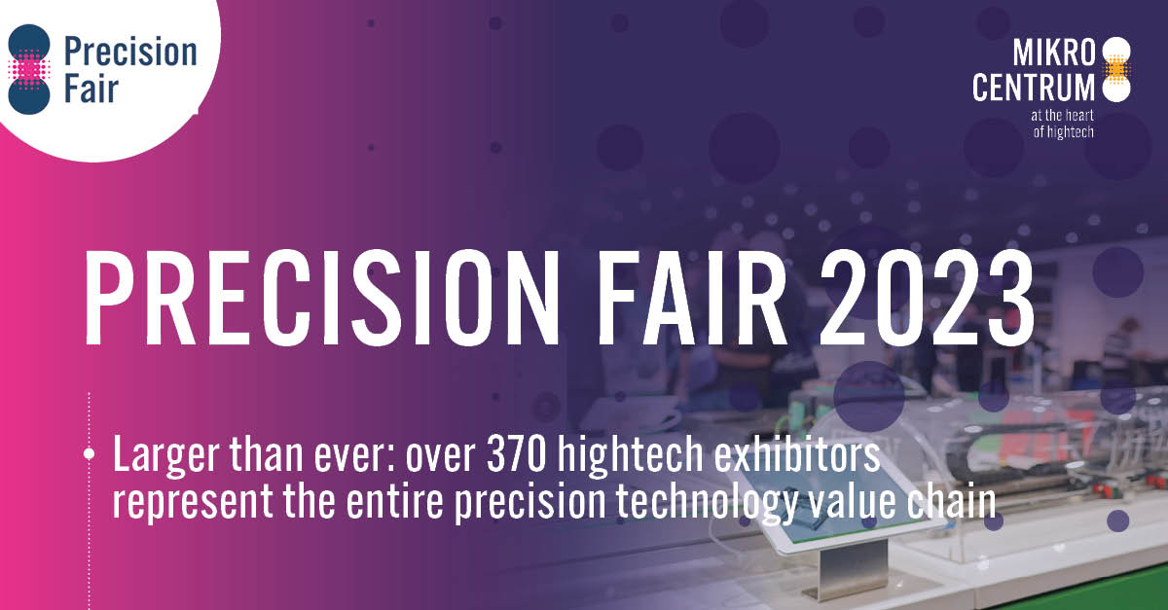

# Expanding Knowledge and Network Across Six Themes

The Precision Fair addresses the most relevant themes in the precision technology sector. Visitors get to meet experts and explore solutions in the following areas: mechatronic engineering & systems, metrology, vacuum & clean, micro processing & motion, laser & photonics, and production for high precision.

Bart Kooijmans, Program Manager of the Precision Fair, says, "I am proud that we facilitate the entire chain in knowledge sharing and making new connections in just two days. This trade fair is known for its accessibility; customers, potential customers, and even competitors walk together on the exhibition floor. Everything is about collaboration, and we provide the space each year to welcome the entire supply chain."

Top professionals from the industry, educational institutions, government agencies, technical universities, and incubator programs come together at the Precision Fair each year. They meet to collaborate on the future to meet the increasing demand for precision.

# AM for Precision Square Focuses on Additive Manufacturing Growth for the High-Tech Sector

One emerging topic that the Precision Fair encourages knowledge sharing about is the rising growth of additive manufacturing applications for precision technology. For several years, Tier 1 suppliers have been building production capacity for additive manufacturing in the semiconductor industry.

The AM for Precision theme square showcases what over 14 suppliers can do and how they apply this in precision engineering. Bart Kooijmans explains, "Here, you will find solutions on how to deal with the latest developments and possibilities for the development of various components, such as 3D metal printing as part of precision technology."

FMI Additive is one of the participants in the AM for Precision theme square. Henk Jansen, Director of FMI Additive, says, "The value seen in 3D metal printing now is that you can create assemblies more easily with fewer process steps. And as long as it involves critical parts, we are competitive in price."

# Various Premieres on the Exhibition Floor: Meet the World's Smallest Coil

The exhibition floor is well represented with 370 exhibitors from the high-tech and precision technology industry. Visitors, for example, get to meet KUK Group, which produces over 200 million coils annually and presents the world's smallest coil with hundreds of windings of ultra-thin wire at the Precision Fair. Laser Technology Janssen showcases a part produced through micro laser cutting. The miniature gear with a diameter of only 1.4 mm is produced in series.

Those who want to learn more about all the ins and outs of the (yet to be built) Einstein Telescope can visit stand 53 of ILO-net (Big Science). Visitors will find everything about this initiative, the project's status, and all the steps the Netherlands is taking to get this project off the ground.

# International Networking Opportunities

For those looking for new networking opportunities, the two-day fair is the right place. The Network Arena is larger than ever and offers visitors the chance to connect with as many as 25 different networking organizations. Additionally, visitors have the opportunity on both days to attend live radio broadcasts from BNR Nieuwsradio, participate in short presentations, workshops, awards ceremonies, and panel discussions. Some highlights include the launch of the latest edition of the PIT magazine, which covers new key technologies, the presentation of the Ir. Davidson Award, the Wim van der Hoek Award by DSPE, and the Young Talent Awards by Mikrocentrum.

# International B2B Matchmaking

As is the case every year, the Enterprise Europe Network, in collaboration with Mikrocentrum, organizes the international B2B matchmaking event. The goal of Meet & Match is to identify relevant contacts throughout the entire supply chain by facilitating personal 1:1 conversations. Visitors can pre-register

[on this website.](https://precision-fair-2023.b2match.io/)

# Knowledge Program with 50 Inspirational Sessions

To facilitate knowledge sharing in the broadest sense, the Precision Fair also brings a diverse knowledge program with it, offering ample inspiration and space for (new) encounters. Bart Kooijmans emphasizes, "The knowledge program includes a range of keynotes and lectures on topics that align with the international ambition of the precision technology value chain. Some examples of lectures include 'Einstein Telescope: Challenges in Seismic Isolation and Vacuum' by Nikhef and 'A VDMA Study on the European Semiconductor Market & Business Climate Outlook' by Dr. Theresa Spaan-Burke. We welcome various distinguished keynote speakers, including Cor Ottens (ASML), Dr. Jessica Steinlechner (Maastricht University), and MTA Group. "And, of course, we are also looking forward to the lecture by Dr. Willem Dijkstra (VDL ETG)!" Bart concludes enthusiastically.

# Free Visit and Registration

The Precision Fair is free to visit at the Brabanthallen, 's-Hertogenbosch (NL) on November 15 and 16. The Precision Fair is organized by Mikrocentrum and supported by the Province of North Brabant, media partners, industry associations, and collaboration partners. More information is available at precisiebeurs.nl (also available for English).

**Over: Mikrocentrum**

Mikrocentrum is het verbindende platform voor de hightech- en maakindustrie. Samen met onze leden, klanten en partners zetten we ons in voor een sterk innovatief ecosysteem, talentontwikkeling en voor de grote maatschappelijke uitdagingen van nu. Wij zijn een onafhankelijke stichting, een opleider, ontmoetingsplek, innovatieversneller en programmamaker. Met opleidingen, evenementen en het High Tech Platform bieden we voor iedereen uit de technologie een plek om kennis te vergroten, kennis te delen en elkaar te ontmoeten. Het uitgangspunt: samen bereiken we meer dan alleen.

**Newsroom**

Bekijk het volledige persbericht inclusief meer foto's en video's in onze Newsroom.

[Bekijk het volledige persbericht](https://mikrocentrum.presscloud.ai/pers/precision-fair-370-hightech-exhibitors-represent-the-entire-precision-technology-value-chain)

[Bekijk alle voorgaande persberichten](https://mikrocentrum.presscloud.ai)