**Precision Fair unites international leaders in hightech to push precision technology boundaries**

**Technological innovations in hightech and precision technology are becoming increasingly complex, making international collaboration essential. On November 13 and 14, the Precision Fair will bring together high-tech companies, professionals and scientists to share the latest insights and opportunities. With over 375 exhibitors, international networking opportunities and a conference program featuring more than 50 keynotes, presentations and workshops, the fair offers a unique opportunity to shape the future of precision technology.**

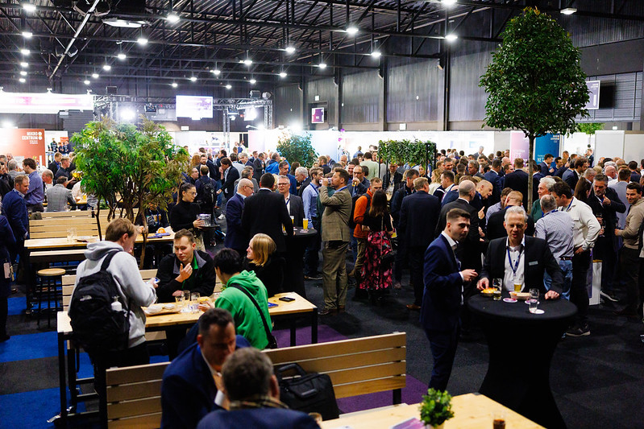

Visitors can also deepen their knowledge across six central themes, each focused on key developments in precision technology: Mechatronic Engineering & Systems, Metrology, Micro Processing & Motion, Production for High Precision, Laser & Photonics, and Vacuum & Clean. Each theme provides access to the latest high- and ultra-precision solutions, as well as opportunities for inspiration and new connections.

**International Collaboration in Focus**

This year, the Precision Fair highlights International Collaboration, welcoming a record number of international delegations. 'Interest from abroad is tremendous, and we are pleased to welcome groups of specialists from around the world,' says Bart Kooijmans, Program Manager at event organizer Mikrocentrum. For example, Lithuania’s short-pulse laser association is joining with four companies and the Irish Precision Tooling & Machining Association is bringing twelve companies. Delegations from Germany, Spain, Italy, and Canada are also represented, including the Canadian Photonics Association and the Swiss Precision Cluster.

**Networking Arena: the beating heart of the exhibition floor**

In the Networking Arena for non-profit organizations, international interest is also prominent. This year, the Precision Fair welcomes new and returning prominent parties, including EPIC (European Photonics Industry Consortium), MinacNed (Microsystems and Nanotechnology cluster), the Digital Industry Boost project, Regieorgaan SIA, RVO, the International Union for Vacuum Science (IUVSTA), the Iam3D Additive Manufacturing association, FPT VIMAG NEVAT, NEN, Utrecht University and Sirris. These organizations join established names that have long made their mark on the field of precision technology.

**Exhibition floor with 375 exhibitors and technological highlights**

Exhibitors from the Netherlands and abroad showcase their most advanced technologies and products, from precision tools and measurement instruments to automation solutions and high-tech materials. Highlights on the exhibition floor include:

* At RESONIKS, visitors discover the benefits of AI-driven acoustic resonance analysis for high-volume production lines.
* LouwersHanique demonstrates the latest applications of ductile CNC micromachining for technical ceramics.
* Sirris inspires with the capabilities of ultrashort pulse laser technology for surface functionality.

**Young Talent and innovative projects in the spotlight**

The Young Talent program showcases the creativity and technical skills of promising student teams presenting impressive projects, including race cars, hydrogen engines and exoskeletons. Visitors can see these teams live on stage for pitches and connect with them in the Networking Arena. During the Best Pitch Young Talent Award on Wednesday, November 13, and the Wim van der Hoek Award on Thursday, November 14, various awards and prizes will be presented to emerging talents and student teams.

**Demo Area: a platform for hightech collaboration**

The Demo Area offers a platform for the latest advancements in Dutch high-tech collaboration, showcasing twelve prominent demo projects, including initiatives from the NXTGEN program. Visitors can explore projects such as Solico’s digital microfactory for lightweight e-mobility, VSparticle’s third-generation electrolyzers, the Nano-Metrology system, SMART Mechatronics, and RoboSapiens.

**Conference Program: knowledge sharing in precision technology and hightech**

This year, the Precision Fair’s two-day conference program features renowned speakers from the Netherlands and abroad across four lecture rooms. Highlights include:

* Speakers from European Big Science projects – leading figures from projects like the Einstein Telescope, James Webb Space Telescope, and European Space Agency (ESA) share insights into scientific and technological advancements.
* Prof. Stuart T. Smith from the University of North Carolina, USA – discusses the latest technological breakthroughs in precision technology.
* Presentations marking 40 years of ASML and 75 years of Thermo Fisher Scientific – with reflections on their past and visions for the future.
* Masterclass GD&T in Action: Applying Theory to Practice – conducted by Mikrocentrum instructor Firat Buyukcivelek.
* Mark Boneschanscher, TU/e EIRES – speaks on modular scaling to accelerate the energy transition.
* Paul Blom, VDL ETG – presents on gaining control over contamination in high-tech environments.

**Collaborative Partners**

The Precision Fair is organized by Mikrocentrum in collaboration with and supported by organizations including CERN, NEVAC, BOM, KIVI, Manufacturing Knowledge Centre, Big Science, Photonics NL, Euspen, EPIC, Holland High Tech, Dutch Precision Technology, Vereniging ION, Enterprise Europe Network, Brainport Industries, VCCN, DSPE, and VDMA.

**Over: Mikrocentrum**

Mikrocentrum is het verbindende platform voor de hightech- en maakindustrie. Samen met onze leden, klanten en partners zetten we ons in voor een sterk innovatief ecosysteem, talentontwikkeling en voor de grote maatschappelijke uitdagingen van nu. Wij zijn een onafhankelijke stichting, een opleider, ontmoetingsplek, innovatieversneller en programmamaker. Met opleidingen, evenementen en het High Tech Platform bieden we voor iedereen uit de technologie een plek om kennis te vergroten, kennis te delen en elkaar te ontmoeten. Het uitgangspunt: samen bereiken we meer dan alleen.

**Newsroom**

Bekijk het volledige persbericht inclusief meer foto's en video's in onze Newsroom.

[Bekijk het volledige persbericht](https://mikrocentrum.presscloud.ai/pers/precision-fair-unites-international-leaders-in-hightech-to-push-precision-technology-boundaries)

[Bekijk alle voorgaande persberichten](https://mikrocentrum.presscloud.ai)